MyChart Scheduling | Patients

Asymptomatic COVID-19 Saliva Testing for JHU
If you are not experiencing any symptoms of COVID-19 and would like to be tested, you are able to schedule a saliva testing appointment via MyChart. If you become symptomatic, do NOT schedule an appointment. Please cancel your appointment and call the Johns Hopkins COVID-19 Call Center (JHCCC) at 833-546-7546 for screening.

Scheduling Asymptomatic Saliva COVID-19 Test

- Log into your MyChart account.
- On the Homepage, select visits, select Asymptomatic COVID-19 Saliva Test and select Schedule Now.
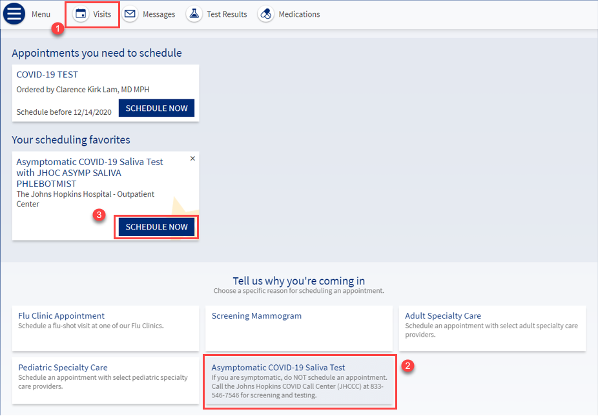
- The system will allow you to pick your location, date and time to schedule saliva test. Multiple sites can also be selected and the times will list grouped under the specific site.
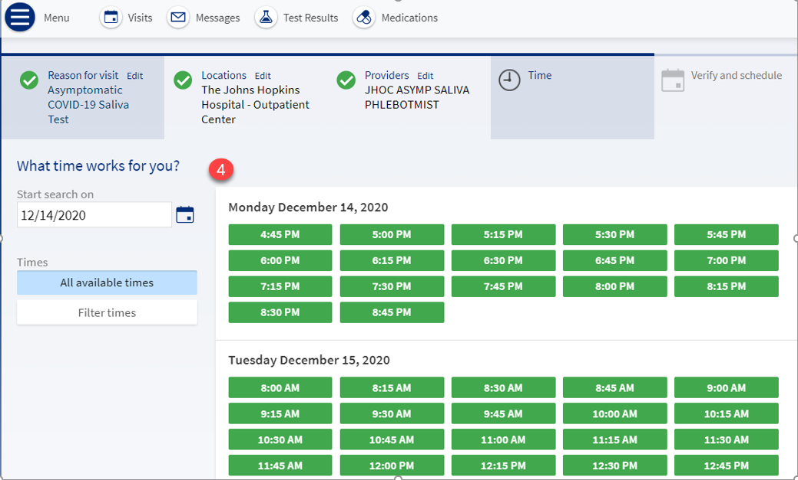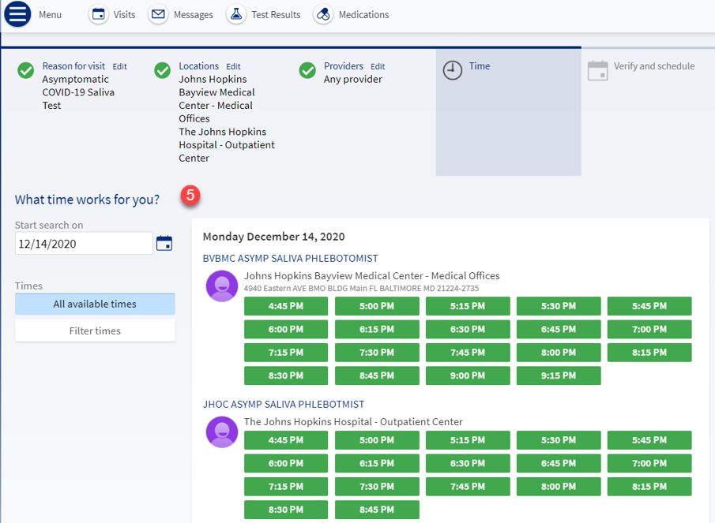
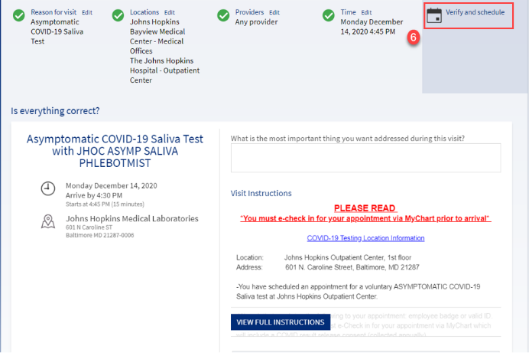
- Verify time, date and location and read the full instructions prior to finalizing appointment. (The screen will say- Is everything correct?) Select Verify and Schedule.

ECHECK-IN for Asymptomatic Saliva COVID-19 Test
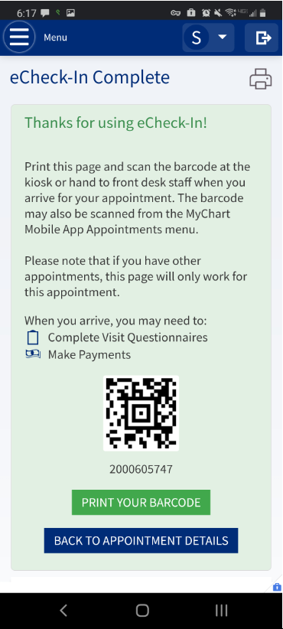
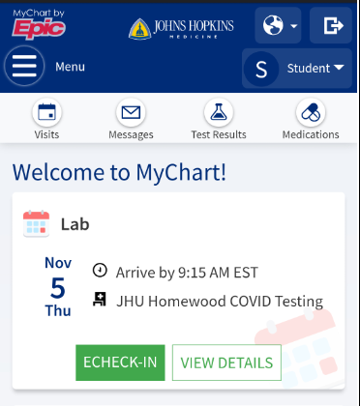
- You can eCheck-in for saliva COVID-19 test in MyChart via phone or computer.
- Select ECHECK-IN and follow prompts. You will receive an eCheck-In Complete notification.

- If you are a JHU employee, you will need to sign a consent (collected annually) for releasing of the results as a part of e-check-in, and this is mandatory. The test will not be able to be completed without this consent signed. Employees must sign the consent form via eCheck-In.
- Select Review and Sign, read and sign document, select Submit.
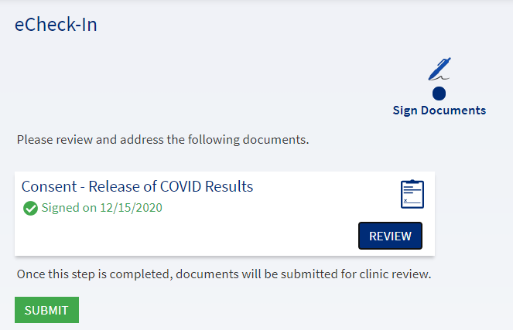
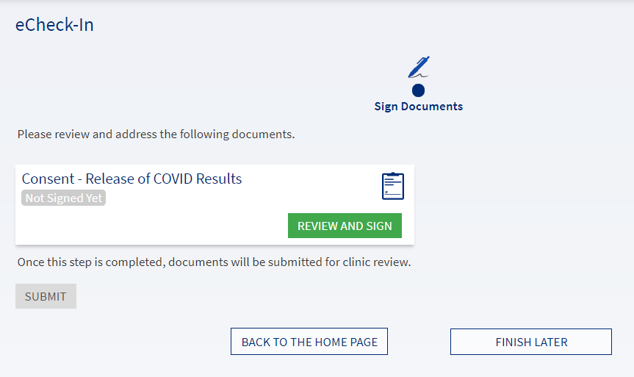

Review Results for Asymptomatic Saliva COVID-19 Test

- MyChart will send an email when results are complete and can be seen in MyChart.
- Select View Results, select Asymptomatic COVID Screen. Results will show on the screen.
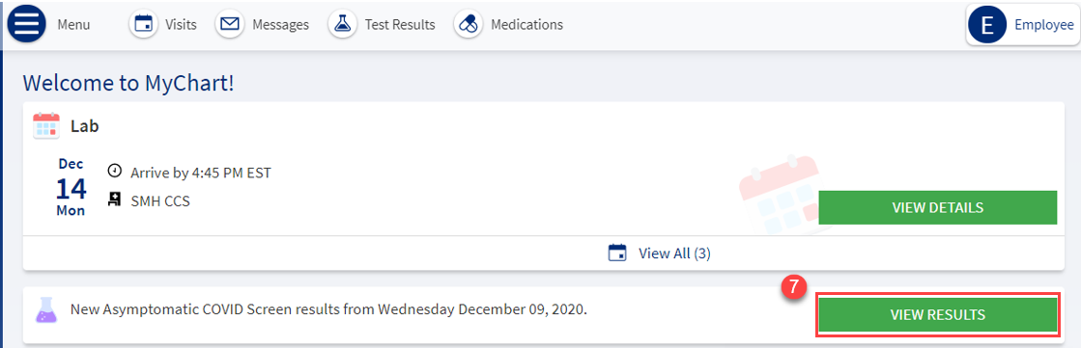
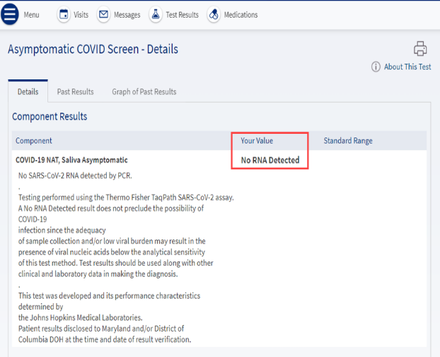
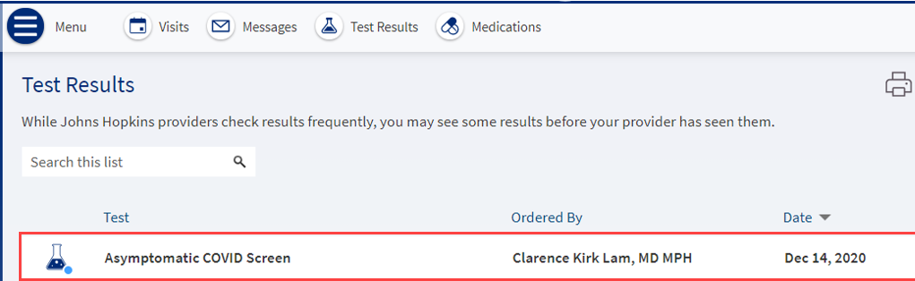

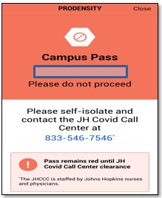
- If your result is positive, the result concurrently generates a case for the JHCCC to follow up and updates your Prodensity status to red. Please self-isolate and notify your manager.

